(Aprox. 310 words)

How Not To Send Your Email to a Bunch of People
(or Just Reply To Sender)
By Lou Cioccio, Board Member, Computer Users of Erie
May 2020 CUE Newsletter
https://www.cuerie.com/
lcioccio (at) mac.com

This happens to me and probably happens to everyone at one time or another whether we are professionals or just "regular" people. In business situations your email, when sending, will have the following:

TO:

CC:

And maybe BCC:

The TO: is sent to the person you are sending to or replying TO: (this IS important for you need to be aware of Reply TO: or Reply TO ALL:). Sometimes someone makes a foolish mistake or broke a mail etiquette rule, and you want to tell him/her but not embarrass the person so you need to Reply TO:, not Reply ALL:, otherwise you are correcting the person amongst him/her peers.

This is one thing I had taught my junior leaders in scouts and also how I handled it
when I was an NCO in the Army. As long as it’s not a life-threatening mistake, you
do not have to make an example to their peers!

On to emails. Here is an example of a person sending an email to a bunch of people rather than having them hidden in BCC, otherwise known as Blind Carbon Copy. Those of you that are old enough will remember Carbon Paper!
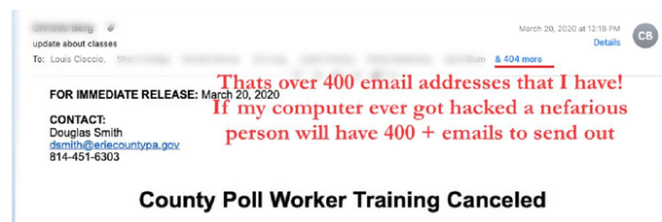
If I expand it this is a partial list about half of those emails!

So, when replying, STOP, make sure you are not replying to the whole Enchilada, only to ONE person. So I hope I did not offend anyone but at least you know and are aware of the difference to Blind Carbon Copy when you do not want to share an address or have something private to say but are letting others know that you sent this email out.

